SproutSong Internship Summary Report

Security, Compliance & Monitoring Documentation Suite

Intern: Dodiya Rudra Ketansinh
Period: May – June 2026
Project: SproutSong / SproutMentors School Management Platform
Role: Security & Compliance Engineering Intern

---

1. Executive Summary

During my internship, I developed a complete security, compliance, and monitoring documentation suite for SproutSong — a school management platform handling student PII, academic records, fee transactions, counselling notes, and Aadhaar-linked data.

The work spanned 11 major documents covering:

· Database security (MongoDB)
· Authentication & session management
· Secure logging & PII masking
· Vulnerability scanning (ZAP)
· Infrastructure monitoring (Uptime Kuma)
· Legal compliance (DPDP Act 2023)
· Breach response & incident handling
· Cookie consent & privacy controls
· AI usage governance

The work also included testing the platform using ZAP, OpenVAS and performing code audits using Snyk as well as generating sample codes for each security implementation aspect, which can be used by the development team. It also included many other minor documents; all of which have been stored in the drive folder.

Every document was built for production deployment with implementation-ready code, configuration examples, and verification checklists.

---

2. Complete Document Inventory

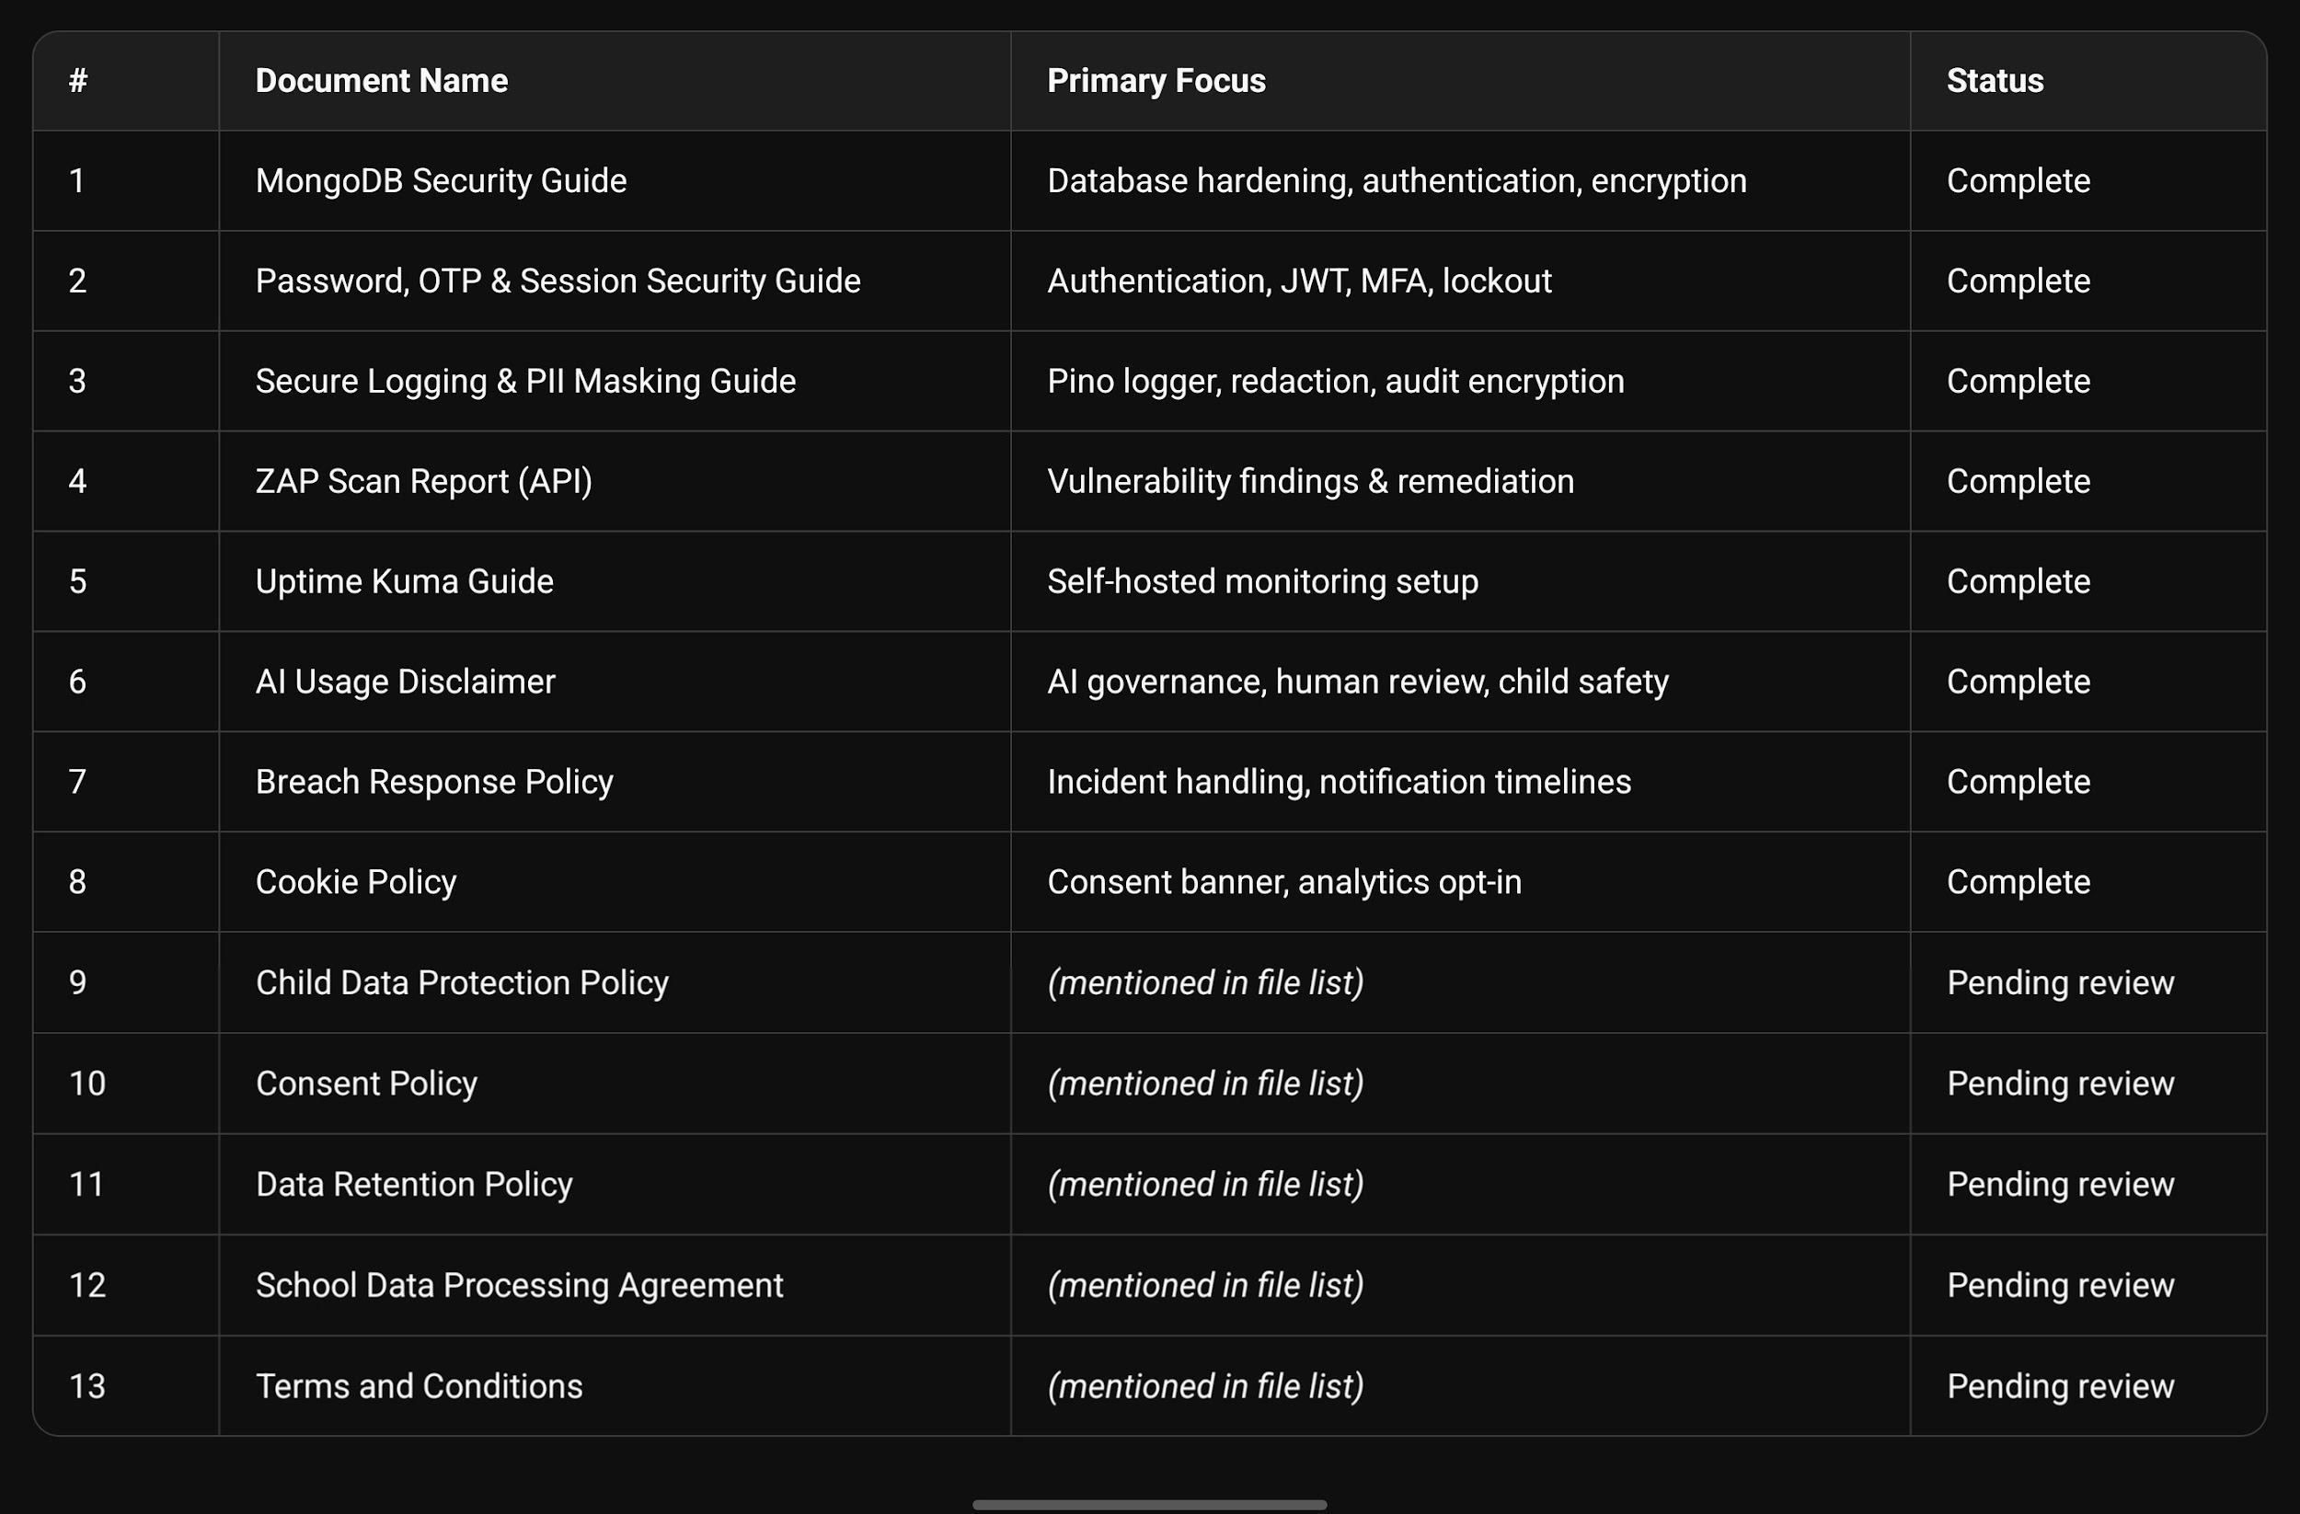
---

3. Document-by-Document Analysis

3.1 MongoDB Security Guide

Why it was made:
SproutSong stores all critical data in MongoDB. A misconfigured database is the most direct path to a catastrophic breach (e.g., 2017 ransomware attacks on 27,000+ exposed MongoDB instances).

What it covers:

· Network hardening: bindIp: 127.0.0.1 only, firewall rules
· Authentication: enabling authorization: enabled
· Separate DB users: sproutsong_app (readWrite), sproutsong_backup (read), sproutsong_admin (userAdmin)
· Mongoose security: strict: true, strictQuery: true, NoSQL injection prevention via express-mongo-sanitize
· Encryption: TLS in transit, LUKS at rest
· Sensitive field handling: bcrypt for passwords, SHA-256 for OTPs, AES-256-GCM for counselling notes
· Mandatory indexes: schoolId first on every multi-tenant collection

Importance:
This is the foundation document for database security. Without it, the entire platform is one exposed port away from complete data loss.

---

3.2 Password, OTP & Session Security Guide

Why it was made:
Credential-based attacks remain the most common breach vector in school management systems. Parents, students, teachers, and admins all have different trust levels requiring differentiated security.

What it covers:

· Password policy: 10+ chars, uppercase+lowercase+number+symbol, bcrypt rounds ≥12
· OTP security: crypto.randomInt() (not Math.random()), SHA-256 hashing, 10-minute expiry, used flag, max 3 attempts
· JWT security: 15-minute access tokens, HttpOnly cookies (not localStorage), tokenVersion for invalidation
· Refresh token rotation & family revocation (detects replay attacks)
· Failed login limits: 5 attempts → 15-minute lockout
· MFA: TOTP for admins, SMS/Email OTP for other roles

Importance:
This document prevents account takeover — the #1 attack vector for SaaS platforms. The anti-enumeration rule (same error for wrong email AND wrong password) alone stops user enumeration attacks.

---

3.3 Secure Logging & PII Masking Guide

Why it was made:
Logs that inadvertently capture PII become a compliance liability and a breach vector (e.g., Twitter 2018 plaintext password logging incident). Under India's DPDP Act 2023, logging student Aadhaar or parent phone numbers is a violation.

What it covers:

· Pino logger (fastest Node.js logger) with built-in redaction
· REDACT_PATHS: passwords, tokens, OTPs, email, phone, Aadhaar, card numbers
· Request ID (correlation ID) for tracing requests across logs
· HMAC-SHA256 for correlatable PII masking (irreversible but deterministic)
· AES-256-GCM for encrypted audit log entries
· Never-log blacklist: student names, parent names, counselling notes, stack traces in production

Importance:
This document ensures SproutSong can debug and audit without violating DPDP. The redaction happens before logs are written — no accidental PII leakage.

---

3.4 ZAP Scan Report (API)

Why it was made:
Before production deployment, automated vulnerability scanning identifies security gaps that documentation alone cannot catch. OWASP ZAP is the industry standard for DAST (Dynamic Application Security Testing).

What it found (11+ alerts):

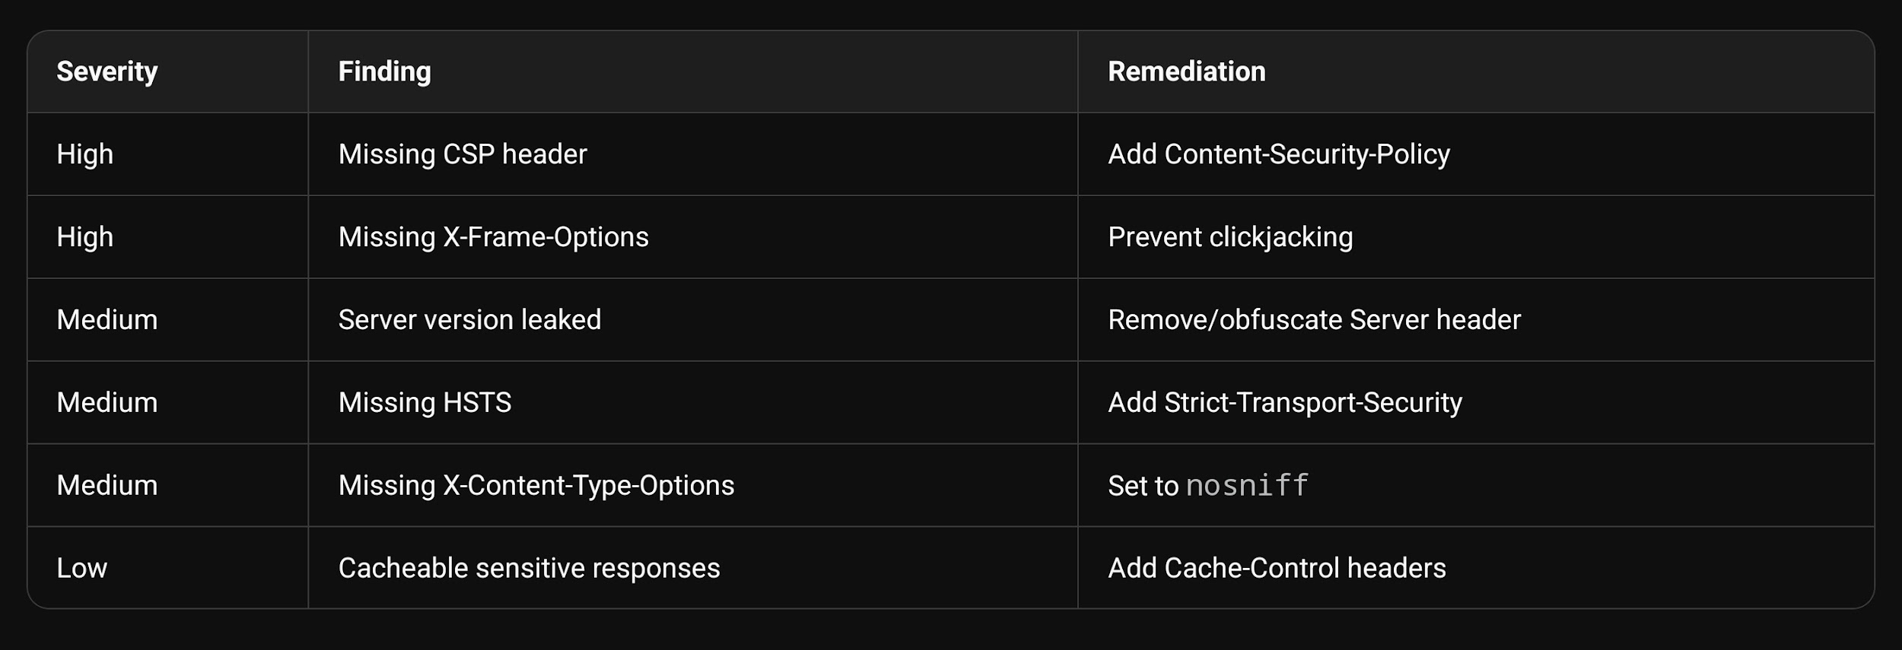

Importance:
The ZAP scan validated that documentation alone isn't enough — actual HTTP headers needed correction. This report became the remediation roadmap for the deployment team.

---

3.5 Uptime Kuma Guide

Why it was made:
A school platform cannot go down without notification. Uptime Kuma provides self-hosted, privacy-preserving monitoring — no third-party cloud service learning about school uptime patterns.

What it covers:

· Docker installation & persistent volume setup
· Monitor types: HTTP(s), TCP port, Ping, Docker container, SSL certificate
· Notification channels: Telegram (instant), SMTP email (backup)
· Public status page creation
· Maintenance window scheduling
· Update procedure (pull, stop, rm, run)

Importance:
This guide enables proactive outage detection — the team knows before parents complain. The Telegram integration means on-call engineers get instant alerts.

---

3.6 AI Usage Disclaimer

Why it was made:
SproutSong uses AI for career guidance, academic analysis, counselling reports, and learning recommendations. Under DPDP and child safety principles, AI cannot make final decisions, cannot label/shame students, and requires human review.

What it covers:

· What AI may be used for (support, not replacement)
· What AI does not do (no psychological diagnosis, no final career decisions)
· Human review requirement for all AI outputs affecting students
· Language that must be avoided: "weak student", "low potential", "will fail"
· Consent notice before AI analysis
· Role-based visibility rules (student sees only their own reviewed reports)
· Correction and challenge rights

Importance:
This document protects SproutSong from legal liability around AI-generated recommendations. It also ensures ethical treatment of students — no harmful labelling.

---

3.7 Breach Response Policy

Why it was made:
Under DPDP Act 2023, a personal data breach requires notification within a specific timeframe. Without a documented response plan, the team would panic and make mistakes during an actual incident.

What it covers:

· Severity classification: SEV-1 (critical) to SEV-4 (low)
· Response timeline: 0-15 min containment, 4-24 hr school notification, 24-72 hr external notification
· Incident-specific playbooks: wrong user access, database leak, file exposure, sensitive logs, email misdelivery, AI report exposure
· Containment code examples: force logout, disable user, feature kill-switch
· Notification templates for schools, parents, and regulators
· Technical incident register (MongoDB schema)
· Post-incident report template

Importance:
A breach response policy is legally required under DPDP for educational platforms. This document transforms panic into procedure.

---

3.8 Cookie Policy

Why it was made:
SproutSong's website uses analytics (Google Analytics/Plausible) and optional marketing cookies. Under DPDP and global privacy laws, non-essential cookies require explicit opt-in consent — especially when children's data is involved.

What it covers:

· Cookie categories: Strictly Necessary (always on), Analytics, Performance, Marketing (all optional)
· Rule: No targeted advertising cookies for students
· Consent banner with Accept All / Reject Non-Essential / Manage Preferences
· Consent storage: browser localStorage + backend database
· React component implementation (full code)
· Backend API for consent logging
· Opt-out mechanism and preference modal

Importance:
This document ensures legal compliance for website tracking. The rule against student ad targeting is ethically critical.

---

3.9 Supporting Documents (In File List)

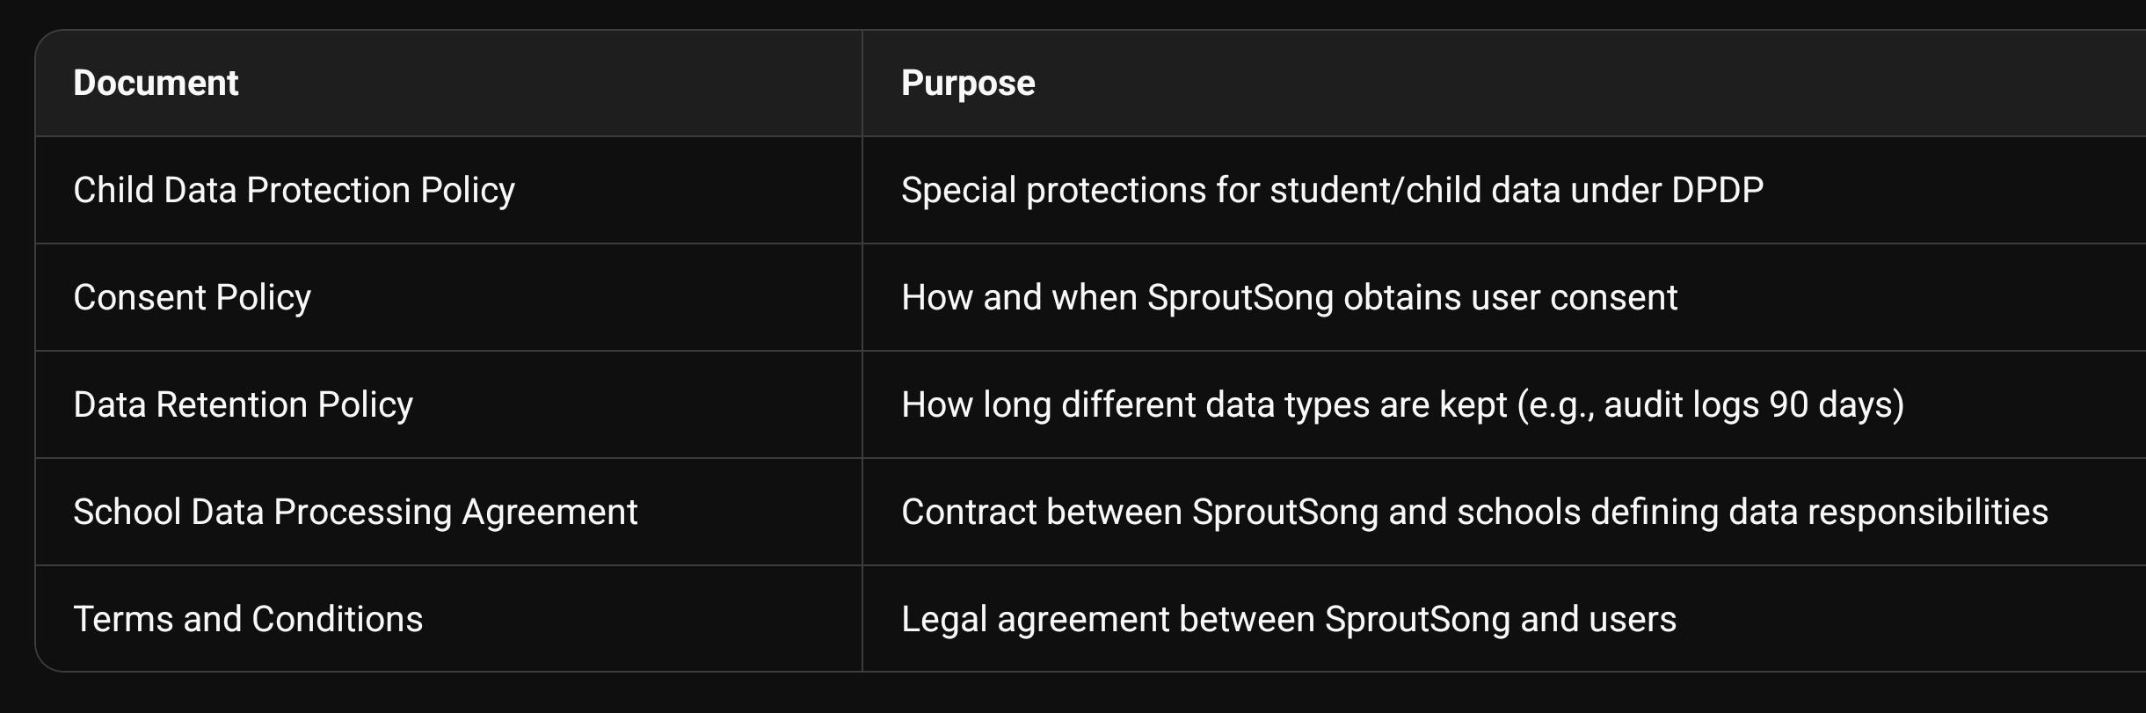

These documents form the complete compliance package required for DPDP Act readiness.

---

4. Key Technical Decisions & Rationale

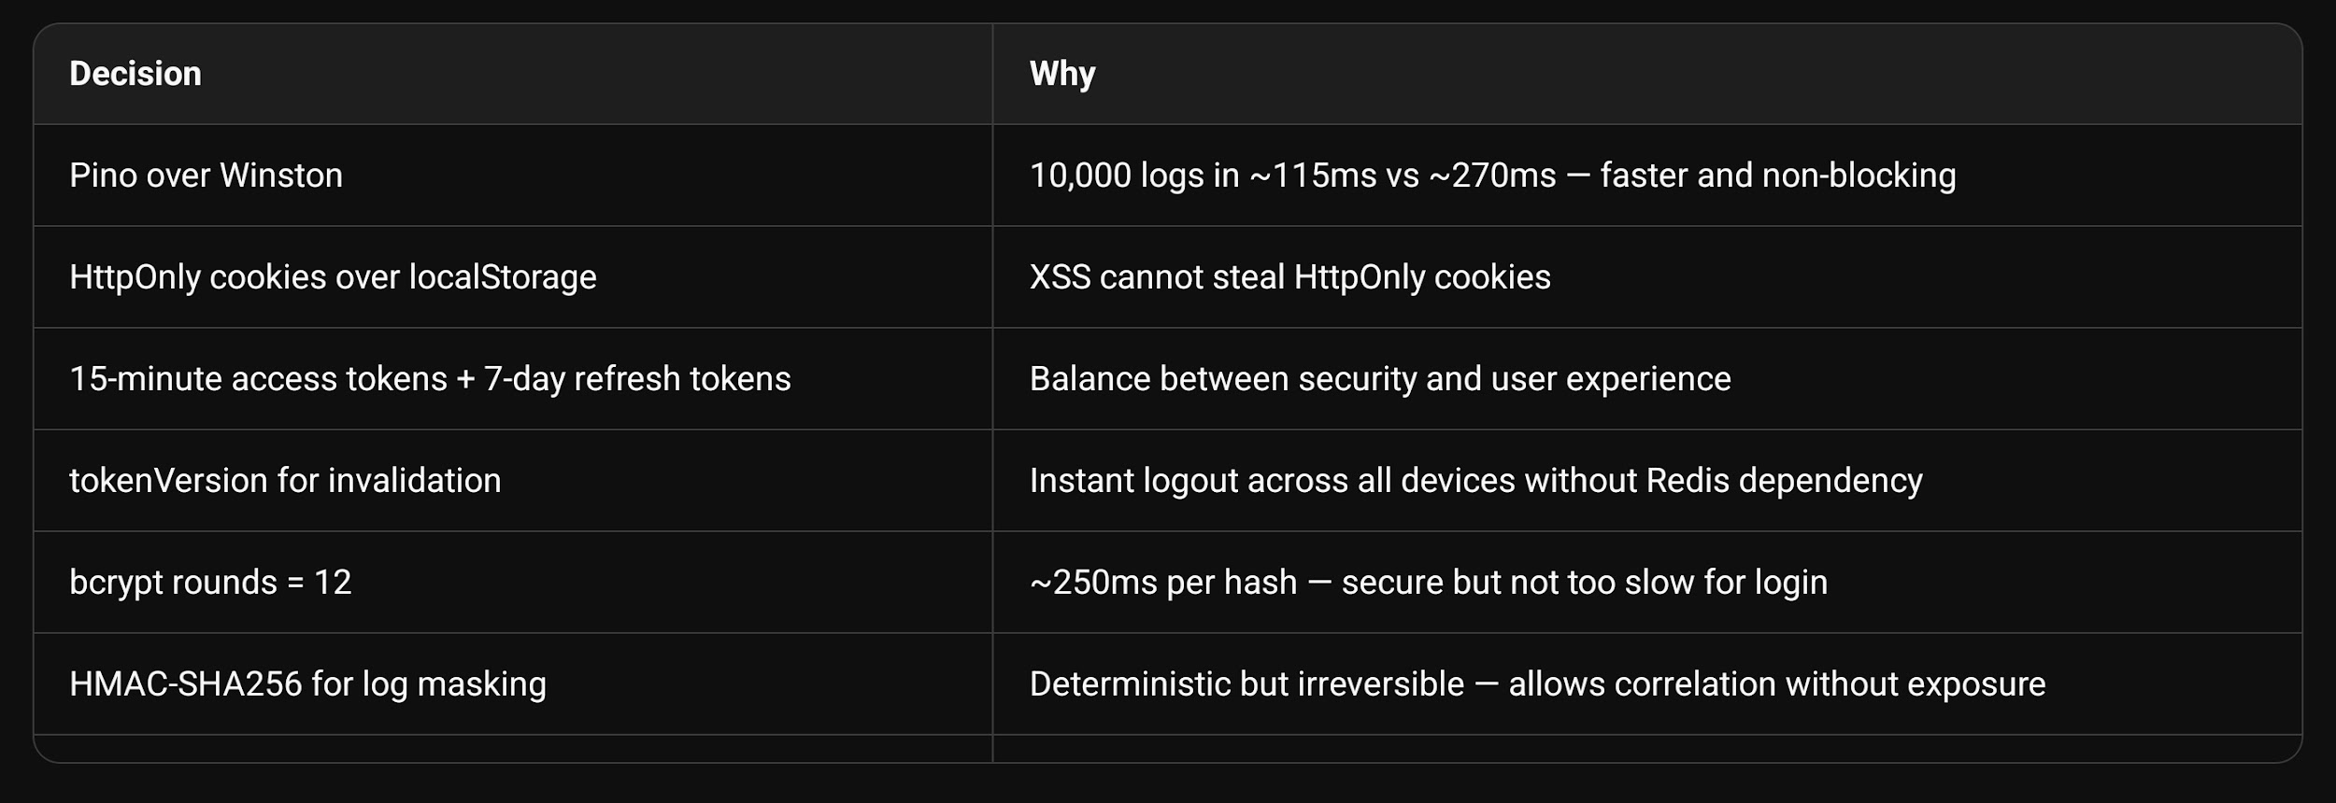
---

5. Compliance Coverage (DPDP Act 2023)

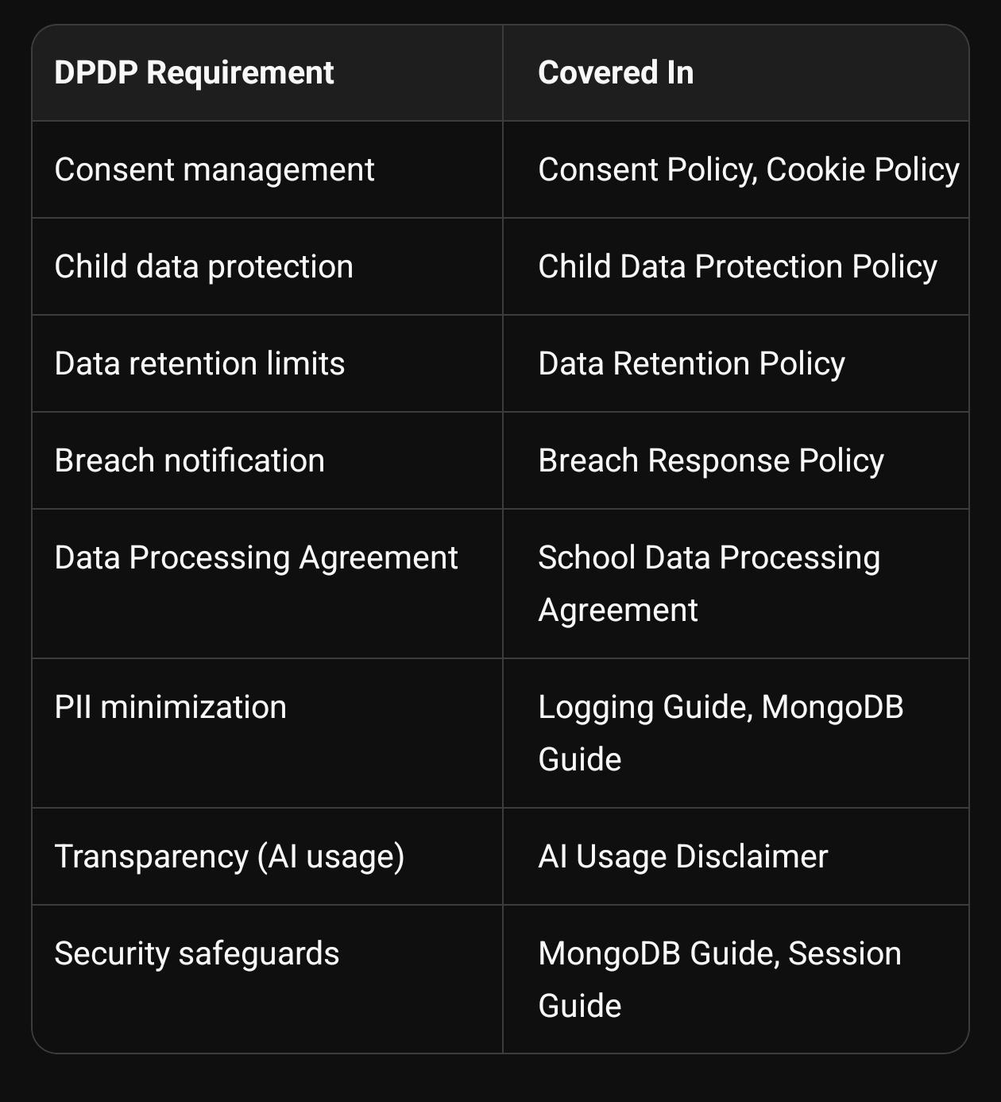
---

6. Skills Demonstrated

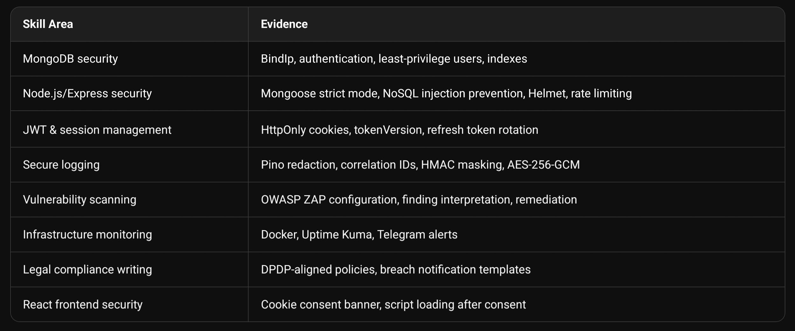

---

7. Impact Assessment

Before this internship:

· No documented security policies
· MongoDB exposed to potential misconfiguration
· No breach response plan
· No logging redaction (PII would leak into logs)
· No vulnerability scanning
· No uptime monitoring
· No AI governance framework

After this internship:

· 11+ production-ready security documents
· Implementation code for every major control
· Legal compliance path for DPDP Act 2023
· Remediation roadmap from ZAP scan
· Monitoring infrastructure documented
· AI usage with human review and child safety

---

8. Deliverables Summary Table

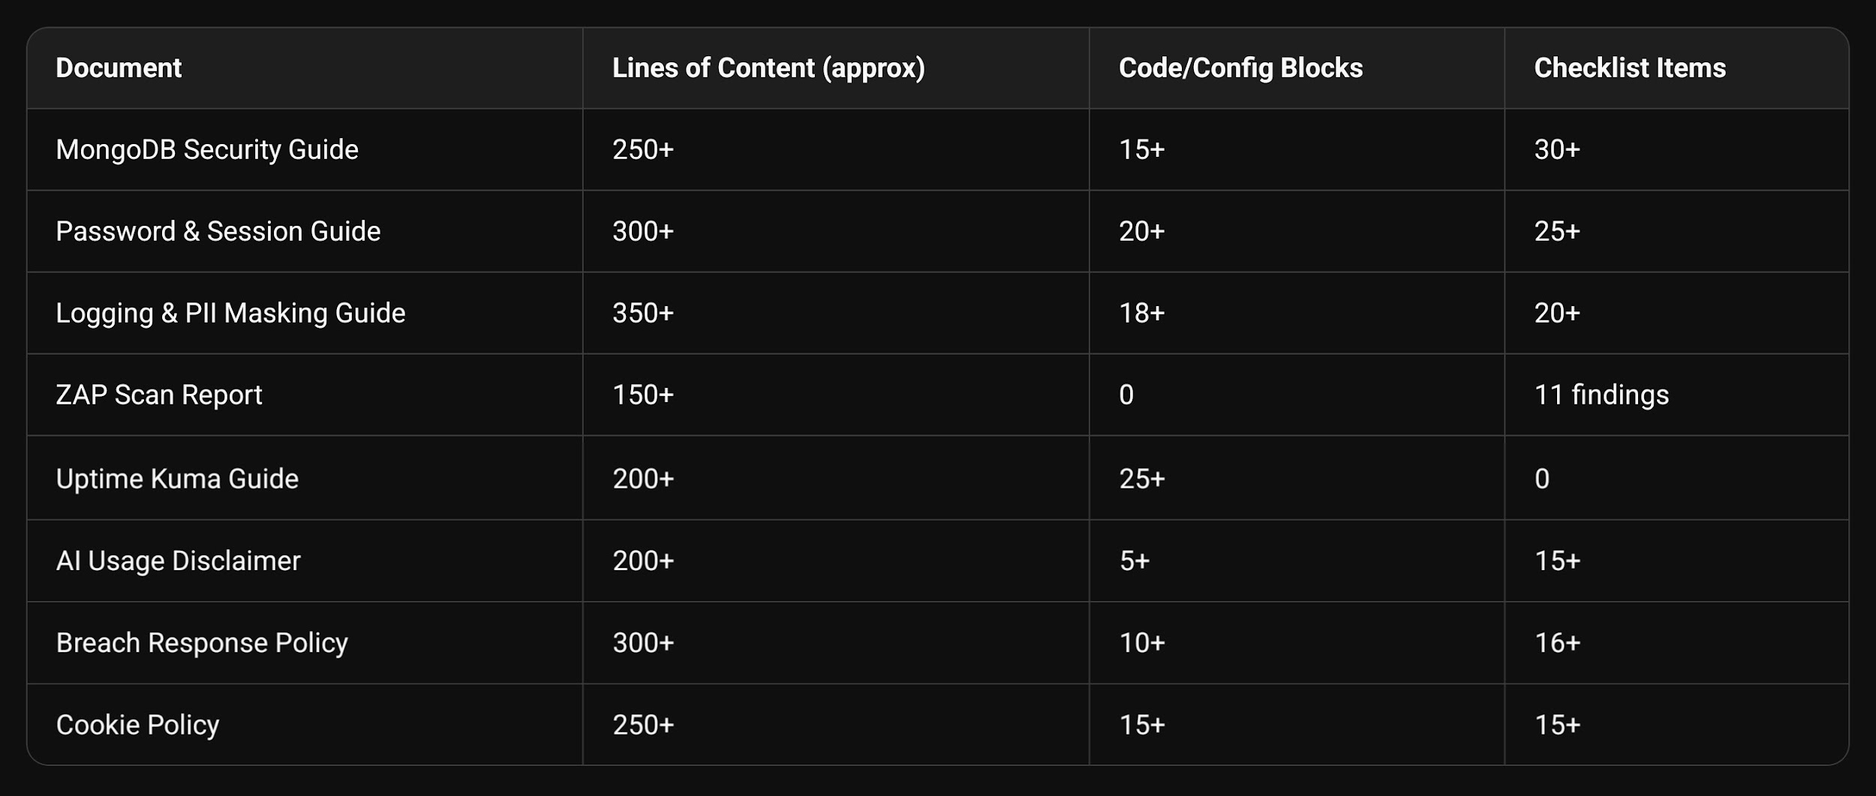

Total: ~2,000+ lines of documentation, 100+ code/config blocks, 130+ checklist items

---

9. Conclusion

This internship produced a complete security and compliance documentation suite for SproutSong School Management Platform. The work was not theoretical — every document includes implementation-ready code, configuration examples, and verification checklists.

The documents collectively address:

· Technical security: MongoDB hardening, JWT security, secure logging, ZAP scanning, uptime monitoring
· Legal compliance: DPDP Act 2023 readiness, breach notification, consent management, data retention
· Ethical AI governance: Human review requirements, prohibition of harmful labelling, child safety
· Operational readiness: Incident response playbooks, backup strategies, recovery testing

The skills demonstrated — from MongoDB security to legal policy writing — reflect the full stack of modern DevSecOps and compliance engineering required for EdTech platforms handling student data.

---

Prepared by: Dodiya Rudra Ketansinh
Internship Period: May – June 2026
Project: SproutSong / SproutMentors
Document Status: Final Summary Report

